**Journey Through The Bible**

**JACOB AND ESAU**

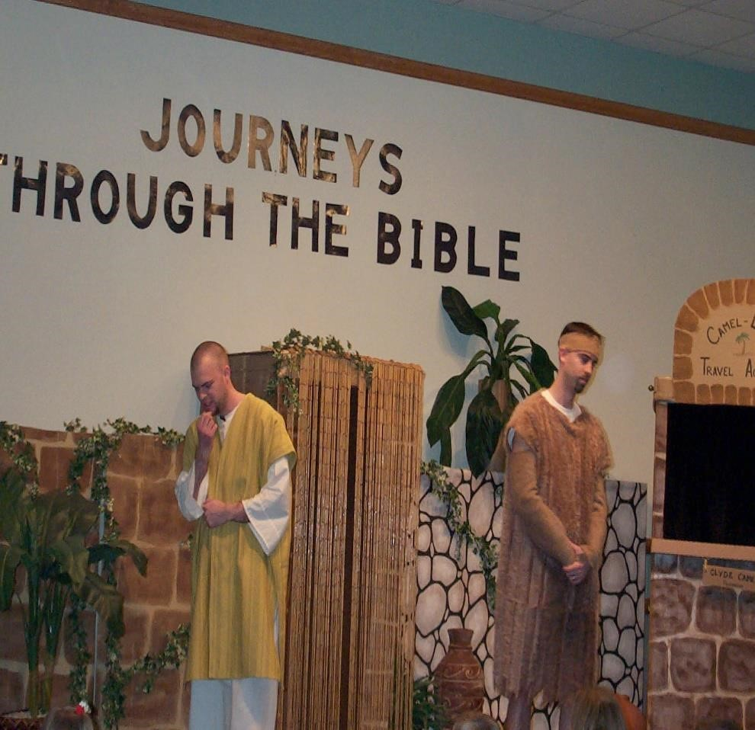

***Esau:***

I am Esau, the son of Isaac and Rebecca. I have a twin brother whose name is Jacob. I was born first.

One day when my dad was old and nearly blind, he called for me. I said, “Here I am.” He didn’t know how long he would live so he had something for me to do for him. He told me to go out into the field and take my bow and arrow and get a wild animal. He wanted me to cook it, make it delicious and take it to him that he might eat it and bless me before he died.

***Jacob:***

My name is Jacob. Our mom was listening when my Dad was talking to my twin brother, Esau. Esau had gone to hunt the wild animal to fix for Dad. Dad loved Esau. Mom loved me. She told me what Dad told Esau to do. She said, “Now I want you to do what I command.” Go get two small goats and I will make good food that he loves for your father. Then take it to him that he may eat it and bless you before he dies. She wants me to get to my dad before Esau. Even though Dad could not see much, I thought he would know it was me. I told Mom that because my skin is smooth and Esau’s is hairy and if my father feels me, he will know that I am Jacob. He will know that I am tricking him. I went and got the goats and Mom cooked the delicious food. Then Mom took some of Esau’s clothes and put them on me. She took the goat skins and put them on my hands and neck so that I would feel hairy.

I took the delicious food and bread that she fixed and went to my Dad. I did not tell him the truth—I told him I was Esau. He wondered why I got there so quickly. I told him God helped me. Dad felt me—he said my voice sounded like Jacob, but my hands felt like Esau. Dad blessed me. He wondered if I were really Esau. I lied to him and said, “I am.” Dad ate the food, kissed me and blessed me.

***Esau:***

After I caught the animal, I fixed the delicious food and took it to my Dad. He asked, “Who are you?” I said that I am Esau, your first-born son. I told him to eat the food. Dad was shaking. He told me that he blessed the one who came before. I wanted him to bless me. Your brother tricked me and took away your blessing. I was very sad and I cried. I hated Jacob.

***Jacob:***

I was afraid of Esau because I had been very bad to him. My Mother said Esau may kill me. She said that I should run away to my uncle’s home in another place. I was there many years. God blessed me with a family and many sheep, camels, and donkeys as I worked for my Uncle Labau. Now I wanted to go home.

When I was nearly home. I looked up and saw Esau coming with 400 men. I put my servants in front and my wives and children in the back. I was afraid of Esau. I saw someone running toward us. It was Esau!

He hugged me and kissed me. We cried. He asked about my family. I told him God had been good to me. I had animals to give to Esau. He said he had enough. I begged him to take them and he did. Esau said, “Let us go on our journey.”

***Esau:***

If you would like to read more about our story, then turn in your Bibles to Genesis. We would like to ask you some questions about our story. (Prepare several questions to ask the boys and girls.)

**Scripture reading**: Genesis 27:1-41; 33:1-16

**Memory Verse:** Romans 12:21

Do not be overcome by evil, but overcome evil with good.